 | 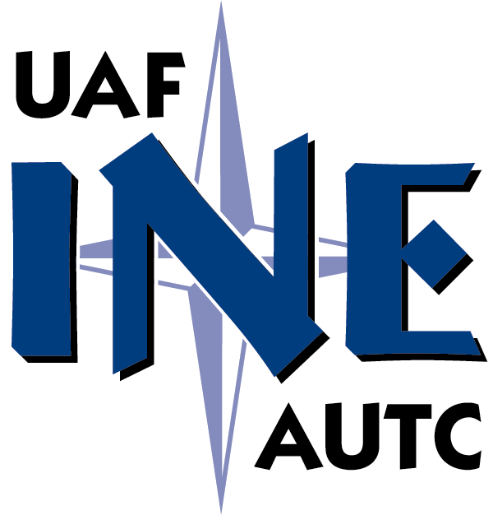 | 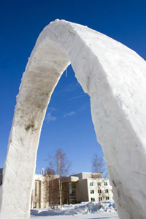

STATE OF ALASKA DOT/PF 2008`````
Annual Statewide Construction Managers Meeting
March 4, 2008

We would like your comments on the concept of a graduate certificate in construction management and any other ideas about how UAF can support training for the AK DOT and its professional staff. Attached are lists of skills, topics, and possible courses. Which of them seem most important to your professional advancement or that of your staff? Are there others? Please email us with your comments.

Dr. Robert A. Perkins, PE  Associate Professor  Civil and Environmental Engineering  University of Alaska Fairbanks  Fairbanks 99775  907 474 7694  ffrap@uaf.edu | F. Lawrence Bennett, P.E.  Professor Emeritus, UAF  Bennett Engineering  947 Reindeer Drive  Fairbanks Alaska 99709 USA  907-479-5118  907-479-6218 (FAX)  907-347-5384 (Cell)  benco@alaska.net

05/27/07

Proposed Topics for Engineering Management Graduate Certificate

Main topics in each area:
1.) Human interactions and communications (4-6 credits)
Ethics and professional responsibility
Human resources laws and practice
Incentive, recognition, and reward systems
Labor relations
Training and development programs
Recruiting, selection, performance appraisal
Leadership
Delegation
Written communications
Oral communications
Visual communications
Negotiations
Proposal writing
Public involvement
Public/media relations
Personal skills/time management

2.) Construction project management (4-6 credits)
Project life cycle
Construction project delivery systems
Project organizations
Project control, work breakdown structure
Project scheduling, CPM, programs
Controls systems
Managing (vs. preventing) changes, & changes affecting professional seals and code requirements
Project initiation, coordination matrix, integration management
Project/regulatory interaction, & inspections by ‘others’ “Stakeholders”
Project termination
Project selection
Project Risk analysis and control
Topics not covered above
Communications management, procurement management, etc.
Accountability for public/owner funds

3.) Construction contract administration (4-6 credits)
General law
Contract law
Public procurement law
Changes and substitutions
Claims
General estimating
Methods
strategies
Record-keeping, accounting management, and work acceptance
Construction equipment management and accounting methods
Financial statements and bonding
Insurance
Contract Administration, including
Contractor Payments
Change Orders
Force Accounts
Claims Management
Project closeout
Specifications
Office procedures
Project safety issues, workers comp and record-keeping
Inspections and Quality Control

4. Understanding in two of these areas: (3-4 credits total)
1.) Asset and maintenance management
2.) Project economics and life cycle costing
3.) Risk analysis
4.) Emergency response
5.) Environmental law and permits/EIS
Project Development and Envir. Documentatioin
7.) Business practices including financial statements

5. Technical topics often mentioned

GPS/GIS, Construction Surveying

